EU Declaration of Conformity (DoC)

Hereby we,
Name of manufacturer: | AURORA SPORTS LIMITED
Address: | #1501-1502, HeChengShiJi Building, WuHe AvenueBantian Town, Longgang District, Shenzhen,GuangDong, CN
Zip code & City: | 518000&Shenzhen
Country: | China
Telephone number: | 0755-23048882

declare that this DoC is issued under our sole responsibility and that this product:
Product description: | Horse Riding Helmet
Type designation(s): | XS-S(48-51CM), S-M(51-55CM), M-L(55-58CM)
Trademark:
Batch / Serial number:
Object of the declaration (further identification of the PPE allowing traceability; it may include a color image for the identification of the PPE):
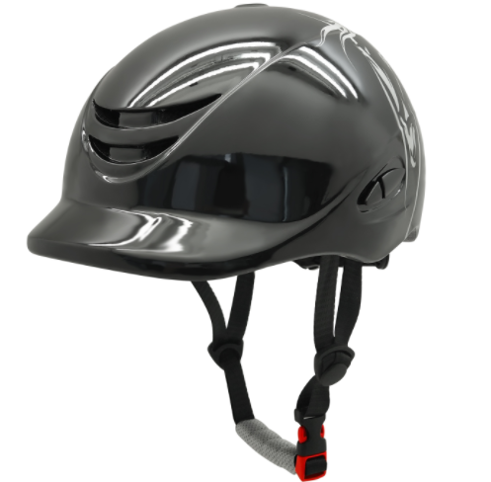……[Insert identification information or photo]……

is in conformity with the relevant Union harmonization legislation:
Protective Product Equipment Regulation: (EU) 2016/425
and other Union harmonization legislation where applicable:

with reference to the following standards applied:
EN 1384:2023 Helmets for equestrian activities

The Notified Body Kiwa NL BV., with Notified Body number 0063 performed:
[choose applicable Modules: B ]

Where applicable:
The issued EU-type examination certificate: [note certificate number]
The conformity assessment procedure (either conformity to type based on internal production control plus supervised product checks at random intervals (Module C2) or conformity to type based on quality assurance of the production process (module D)) under surveillance of notified body (name, number).

Additional information: (accessories)
.…………………………………………………………………………………………………………

Signed for and on behalf of:

_________________________ ______________________________
Place and date of issue Name, Function, signature

